**UX DESIGN: 4 IDEATION**

**Welcome**



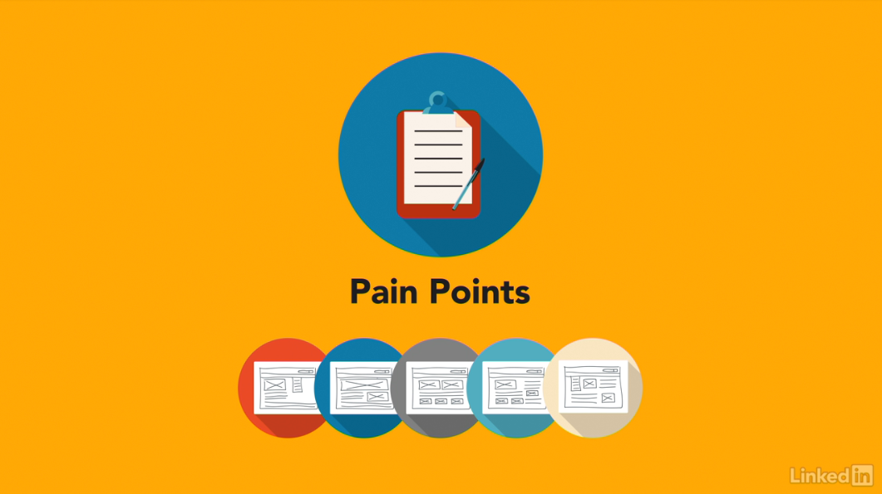

[Hello, I'm Chris Nodder. Welcome to the fourth episode of the UX Design Techniques series. In this episode, we'll discuss ideation techniques. That is, ways to find creative solutions to your interface issues. This is the fourth course in a series that describes a set of techniques you can use to make your development process more user-centered. In this installment, I'll show you how to generate multiple creative ideas for fixing the user pain points you uncovered in earlier stages of the process. Ideation is a technique that lets you explore lots of different design ideas in a very short space of time, drawing on the diverse ideas that each member of the team can bring to the table. Having a broad set of ideas to draw from makes it much more likely that you'll come up with a suitable solution. Now it's time to dive in and learn about ideation techniques that you can use to unleash the creativity of your team and explore many potential ways forward for your product. So let's get started.](https://www.linkedin.com/learning/ux-design-4-ideation/welcome?resume=false)

1. **Adding Creativity to the User-Centered Design Process**

**What does ideation mean?**

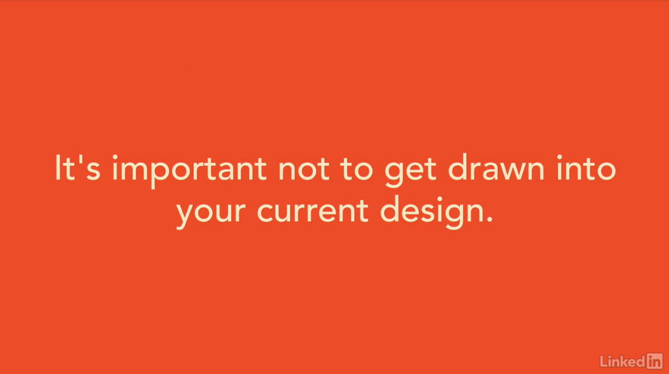

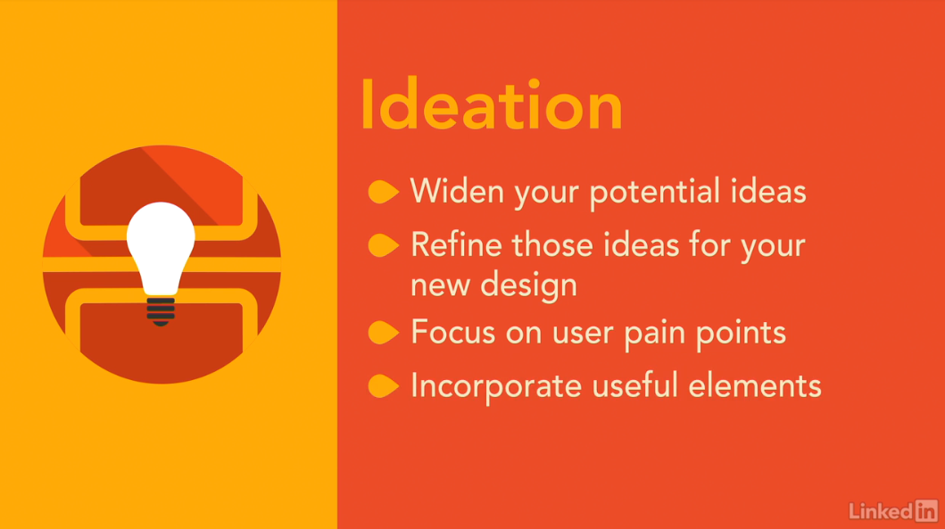

[When you have an idea about how something should be, it's hard to get that idea out of your mind and explore alternatives. It's a bit like having a song stuck in your head. Even if the song's a good one, it's likely that you don't want to keep listening to it forever. Instead, you probably want some variety. It's the same with interface design. Maybe you already have some ideas about your interface should be. Perhaps you have already built it and have a working version. It's hard to get this version out of your head and explore alternatives. But, it's important not to get drawn into your current design. Even if it's performing well, you might find that it doesn't solve all of your users' problems. Finding alternative designs that might solve these problems involves letting go of your current design for a while. That's the process of ideation. With ideation, you widen the set of potential ideas you could draw from to make your interface better and then you refine a set of these ideas and use them as the basis for your new design. The ideation process frees you up to think about solutions to your users' pain points without having to focus on the constraints of your current design or the current way of doing things. Even if you aren't able to implement the ideas you come up with directly, elements of those concepts will undoubtedly be useful as you move towards a design solution.](https://www.linkedin.com/learning/ux-design-4-ideation/what-does-ideation-mean?autoSkip=true&resume=false)

**The local maximum problem**

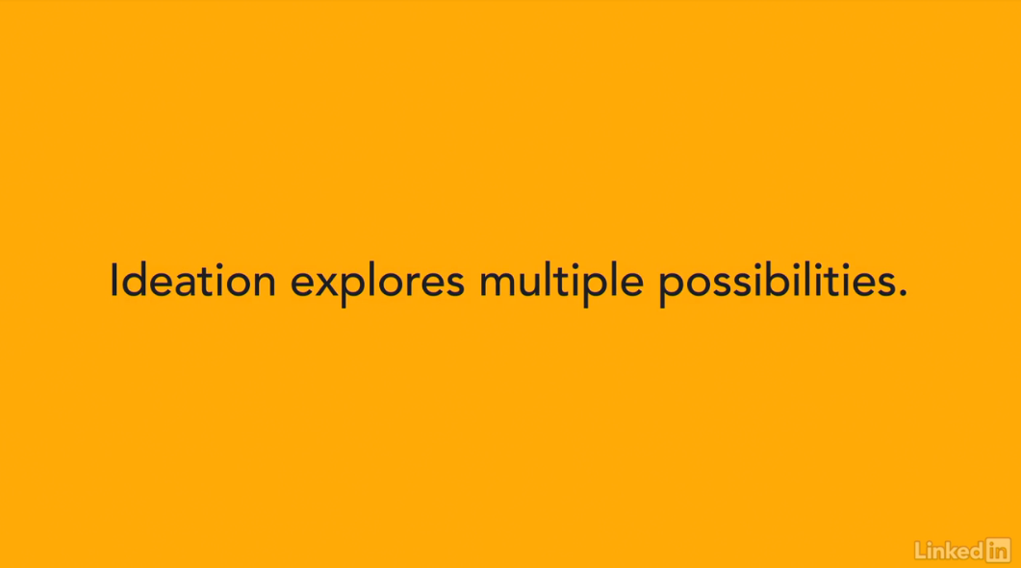

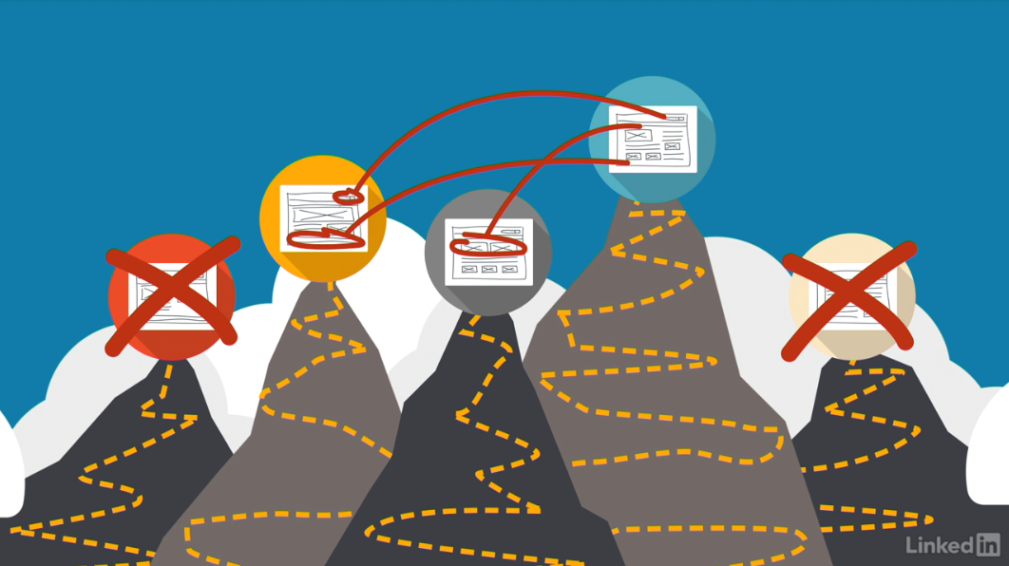

[So, why would you want to create a whole set of ideas when, ultimately, you'll only going to be using one of them? You do this to avoid falling into the local maximum trap. The local maximum is a way of describing your ability to design the best possible product. Imagine that you're exploring a new area. You're trying to climb up the highest hill, but while you're climbing up a hill, you don't know how tall it's going to be. It's not until you've explored several different hills that you can work out which is the tallest. Now, imagine that the hills in this description are actually different designs that you could use. You don't know which is the best design, the one at the top of the tallest hill, until you've explored several different hills. It doesn't make sense to just keep climbing up the hill that you're on right now, because who knows whether there's a taller hill, that is, a better design, until you've explored several different alternatives. And that's what ideation does. It avoids the local maximum trap by helping you explore several alternative designs before you get too engrossed in any one way of doing things. Rather than just following one single track, you take a short period of time to explore multiple possibilities. Some may end up not being possible, others may not seem too useful, but a few will give you new ideas that you can integrate into your design process in order to create the best possible solution for your user's needs.](https://www.linkedin.com/learning/ux-design-4-ideation/the-local-maximum-problem?autoSkip=true&resume=false)

**The benefits of ideation techniques**

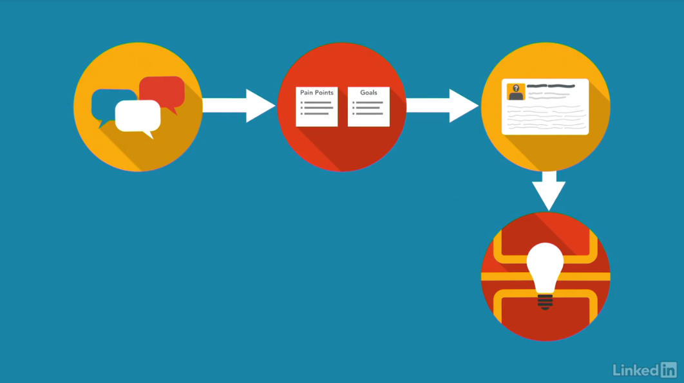

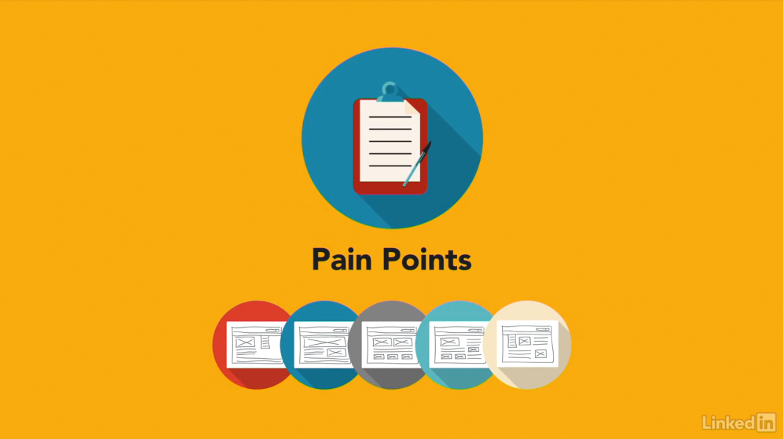

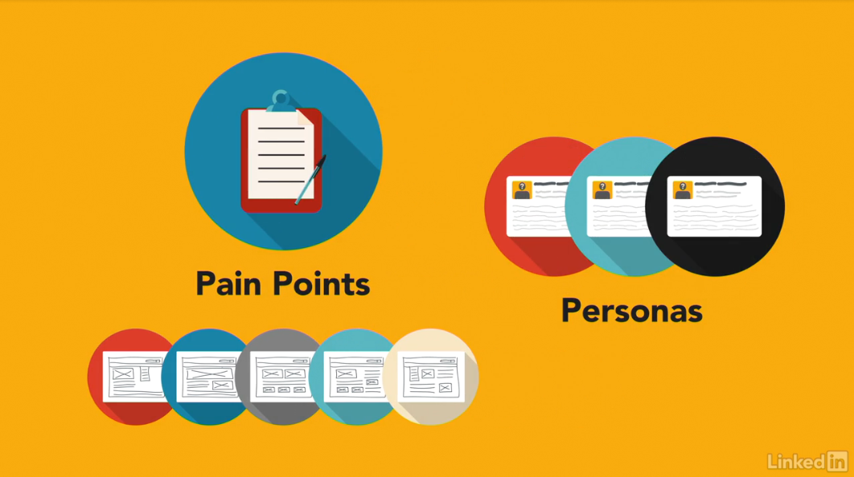

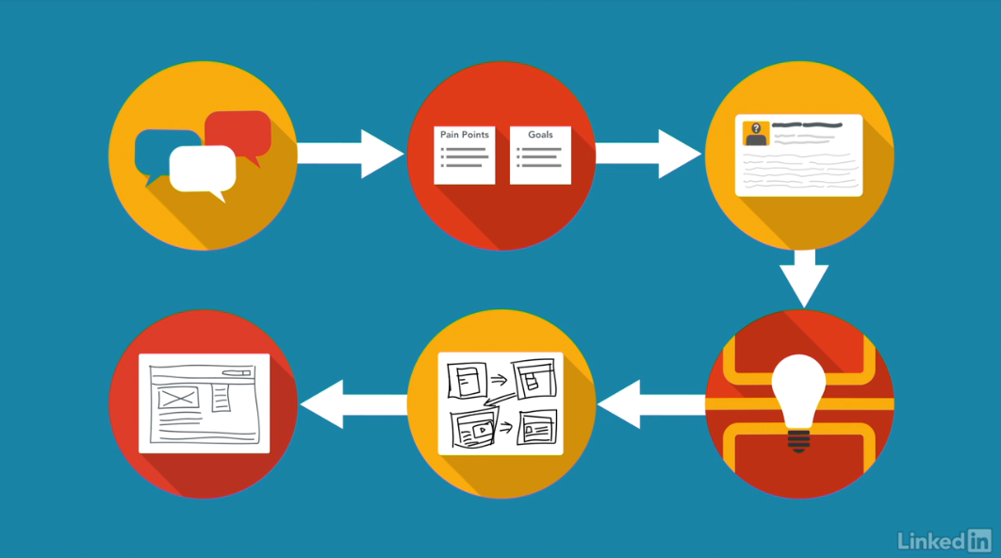

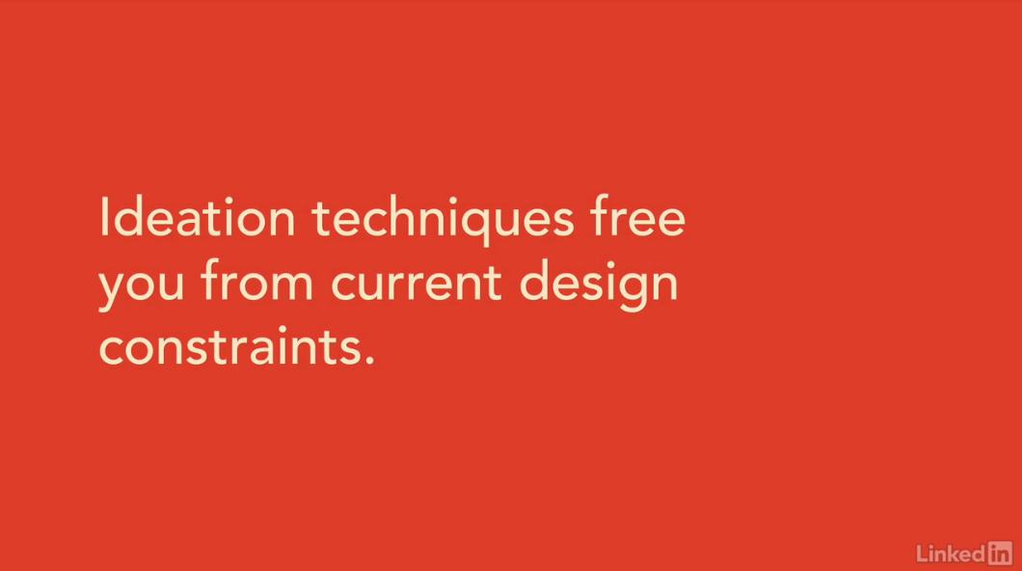

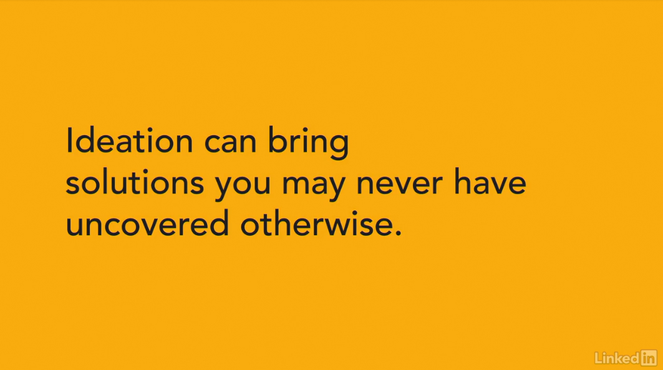

[Ideation fits into the user-centered design process right after you've discovered your user's pain points and decided upon your personas.](https://www.linkedin.com/learning/ux-design-4-ideation/the-benefits-of-ideation-techniques?resume=false)

[Ideation techniques allow you to generate multiple potential solutions to the pain points you uncovered.](https://www.linkedin.com/learning/ux-design-4-ideation/the-benefits-of-ideation-techniques?resume=false)

[The information that you need to do the ideation work comes from your experience map, and the list of pain points and goals you created. Obviously, you need some focus for the ideation process, and that's where your personas help, by providing a reality check.](https://www.linkedin.com/learning/ux-design-4-ideation/the-benefits-of-ideation-techniques?resume=false)

[After doing an ideation exercise to discover multiple possible paths, you'll narrow your focus and bring things back to reality somewhat by creating scenarios and storyboards.](https://www.linkedin.com/learning/ux-design-4-ideation/the-benefits-of-ideation-techniques?resume=false)

[These tools describe the design ideas that you've chosen to follow as a result of the ideation exercise. They turn the abstract design ideas into specific, understandable, actionable items.](https://www.linkedin.com/learning/ux-design-4-ideation/the-benefits-of-ideation-techniques?resume=false)

[By showing how the ideation concept would apply to your personas, creating a day-in-the-life story of the persona's interaction with the new design concepts. After you have your scenarios and storyboards you can create a prototype user interface to test out those ideas, and refine them, before committing anything to code.](https://www.linkedin.com/learning/ux-design-4-ideation/the-benefits-of-ideation-techniques?resume=false)

[In this way, you save time and money by working out what you plan on building early in the process, before it gets costly to make changes.](https://www.linkedin.com/learning/ux-design-4-ideation/the-benefits-of-ideation-techniques?resume=false)

[Ideation techniques free you from your current design constraints.](https://www.linkedin.com/learning/ux-design-4-ideation/the-benefits-of-ideation-techniques?resume=false)

[Rather than trying to just add new pieces onto your current interface, the equivalent of trying to climb the same hill, you'll explore some alternatives that might just take you in a new direction that let's you climb a taller hill and create a design that better suits your user's needs.](https://www.linkedin.com/learning/ux-design-4-ideation/the-benefits-of-ideation-techniques?resume=false)

[Ideation involves the whole team, in generating multiple different alternative design ideas and allows you to perform a design reset so that you can assess different alternatives and set off on a path that's more likely to meet your user-centered design goals.](https://www.linkedin.com/learning/ux-design-4-ideation/the-benefits-of-ideation-techniques?resume=false)

[It's amazing how creative different team members can be when you give them the opportunity.](https://www.linkedin.com/learning/ux-design-4-ideation/the-benefits-of-ideation-techniques?resume=false)

[Ideation exercises are an opportunity to draw that creativity out. Let everyone on the team feel like they've contributed to the solution that you decide to go with.](https://www.linkedin.com/learning/ux-design-4-ideation/the-benefits-of-ideation-techniques?resume=false)

[The benefit of this type of exercise should be obvious. You inject new ideas into your design process and the creativity you unleash on the team leads to solutions you may never have uncovered otherwise.](https://www.linkedin.com/learning/ux-design-4-ideation/the-benefits-of-ideation-techniques?resume=false)

1. **Ideation Techniques**

**Brainstorming doesn’t always work**

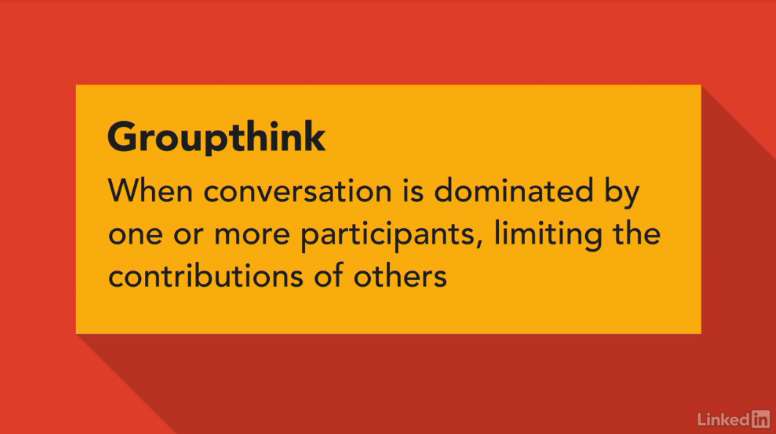

[Our first solutions are rarely our best.](https://www.linkedin.com/learning/ux-design-4-ideation/brainstorming-doesn-t-always-work)

[Also, a single person can only leverage their own individual understanding of a problem. Their design ideas are bound by personal experience.](https://www.linkedin.com/learning/ux-design-4-ideation/brainstorming-doesn-t-always-work)

[For that reason, most ideation techniques involve getting several people together to generate different concepts and then build off each other's ideas to create an overall composite idea that incorporates elements of the most promising individual pieces.](https://www.linkedin.com/learning/ux-design-4-ideation/brainstorming-doesn-t-always-work)

[Working as a team to ideate and consider multiple solutions helps us get to a more well rounded product. One well known ideation technique is brainstorming, where a group gets together in a room and calls out ideas, building off each others thoughts.](https://www.linkedin.com/learning/ux-design-4-ideation/brainstorming-doesn-t-always-work)

[However, one problem with brainstorming and similar techniques is that it can lead to group think. That is, when one or more of the participants start taking over the conversation. Either because they are the most senior, the most respected, or just the loudest.](https://www.linkedin.com/learning/ux-design-4-ideation/brainstorming-doesn-t-always-work)

[Other people in the room, either feel uneasy saying something different or don't think for themselves so never consider alternatives.](https://www.linkedin.com/learning/ux-design-4-ideation/brainstorming-doesn-t-always-work)



[This leads to a situation where creativity is reduced because one person dominated. The best types of ideation techniques are ones which prevent the group think problem by having individuals work separately to start with then come together to share ideas, discuss, learn and get creative.](https://www.linkedin.com/learning/ux-design-4-ideation/brainstorming-doesn-t-always-work)

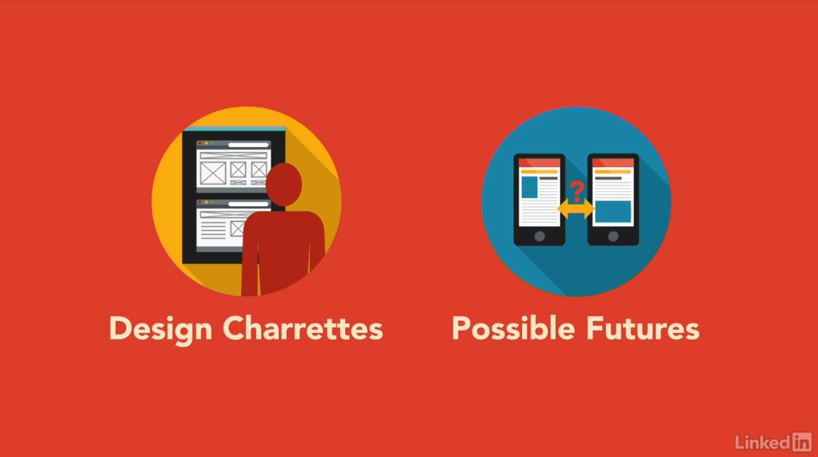

[Two techniques that I like to use are Design Charrettes and Possible Futures. Both of these approaches to ideation allow individuals to do a bit of thinking on their own before they come together as a group.](https://www.linkedin.com/learning/ux-design-4-ideation/brainstorming-doesn-t-always-work)

[They also give everyone in the session time to describe their design, rather than running the risk of being shouted down by stronger voices.](https://www.linkedin.com/learning/ux-design-4-ideation/brainstorming-doesn-t-always-work)



[Apart from being more democratic, I think these techniques also lead to better ideas being generated. Often, it's the quiet, thoughtful team members who come up with the most novel and extraordinary new ideas.](https://www.linkedin.com/learning/ux-design-4-ideation/brainstorming-doesn-t-always-work)

[What you need are tools that help these to share their thoughts rather than being pushed down by louder or more confident colleagues who may have spent more time talking than thinking. We'll discuss the two ideation techniques I mentioned that work this way, Design Charrettes and Possible Futures, next.](https://www.linkedin.com/learning/ux-design-4-ideation/brainstorming-doesn-t-always-work)

**The design charrette ideation techniques**

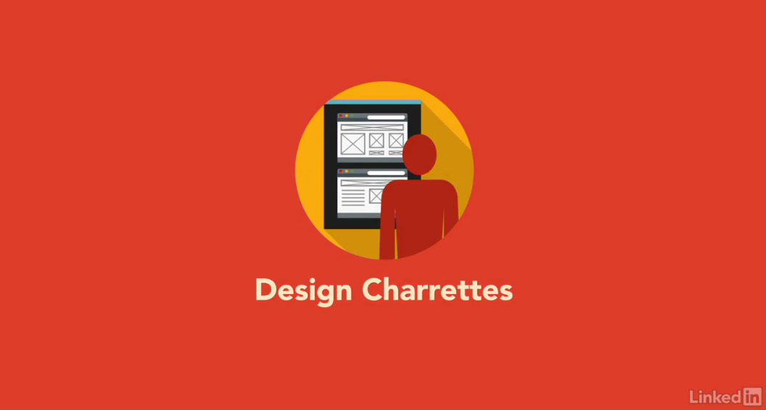

[One of my favorite techniques among which all team members can participate in is the design charrette.](https://www.linkedin.com/learning/ux-design-4-ideation/the-design-charrette-ideation-techniques?autoSkip=true&resume=false)

[This technique is also sometimes known as design studio. The idea is very simple, and it's easy to make it non-threatening, even to people who claim they can't do design work. It involves five simple steps.](https://www.linkedin.com/learning/ux-design-4-ideation/the-design-charrette-ideation-techniques?autoSkip=true&resume=false)

[First, review the problem statement and user research as a team.](https://www.linkedin.com/learning/ux-design-4-ideation/the-design-charrette-ideation-techniques?autoSkip=true&resume=false)

[Second, on your own, sketch your product solution ideas, using whichever technique works for you.](https://www.linkedin.com/learning/ux-design-4-ideation/the-design-charrette-ideation-techniques?autoSkip=true&resume=false)

[Third, together as a group, critique each design idea and identify the concepts you want to be sure to keep.](https://www.linkedin.com/learning/ux-design-4-ideation/the-design-charrette-ideation-techniques?autoSkip=true&resume=false)

[Fourth, work in pairs to synthesize the good concepts and come up with the next better design concept. Finally, together as a group again, critique these new designs and make some final decisions about the solutions you'd like to carry through into prototypes.](https://www.linkedin.com/learning/ux-design-4-ideation/the-design-charrette-ideation-techniques?autoSkip=true&resume=false)

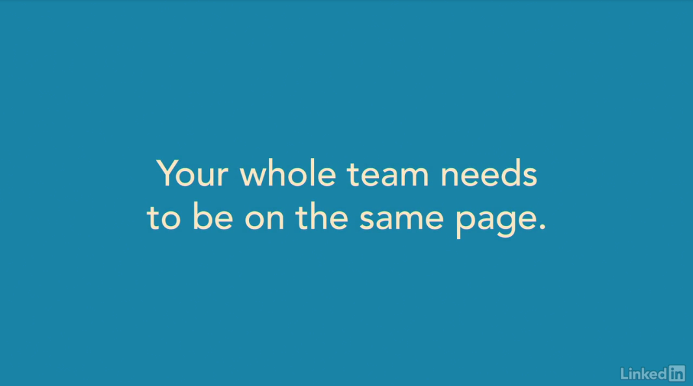

[Now, let's discuss each of these steps in more detail, so that you can replicate them and run your own design charrette.](https://www.linkedin.com/learning/ux-design-4-ideation/the-design-charrette-ideation-techniques?autoSkip=true&resume=false)

[First, the whole team needs to be on the same page about what the problem is that they're trying to solve, and what you already know about user behaviour in this area.](https://www.linkedin.com/learning/ux-design-4-ideation/the-design-charrette-ideation-techniques?autoSkip=true&resume=false)

[That's where your experience map comes in handy. The whole team should have been involved in site visits, and creating the experience map.](https://www.linkedin.com/learning/ux-design-4-ideation/the-design-charrette-ideation-techniques?autoSkip=true&resume=false)

[Now, it's time to review that data so that everyone feels confident knowing what the pain points are that led to your problem statements and goals.](https://www.linkedin.com/learning/ux-design-4-ideation/the-design-charrette-ideation-techniques?autoSkip=true&resume=false)

[The team also needs to know who the personas are that would use the solutions you create.](https://www.linkedin.com/learning/ux-design-4-ideation/the-design-charrette-ideation-techniques?autoSkip=true&resume=false)

[Your personas provide a summary description of the key users of your product.](https://www.linkedin.com/learning/ux-design-4-ideation/the-design-charrette-ideation-techniques?autoSkip=true&resume=false)

[Keep them prominently displayed so that it's clear who the team is designing for.](https://www.linkedin.com/learning/ux-design-4-ideation/the-design-charrette-ideation-techniques?autoSkip=true&resume=false)

[If you have the time, it's worth doing a different charrette exercise for each of your problem statements.](https://www.linkedin.com/learning/ux-design-4-ideation/the-design-charrette-ideation-techniques?autoSkip=true&resume=false)

[Although, often, you'll find that people's design output from the charrette sessions solves more than one of the problem statements.](https://www.linkedin.com/learning/ux-design-4-ideation/the-design-charrette-ideation-techniques?autoSkip=true&resume=false)

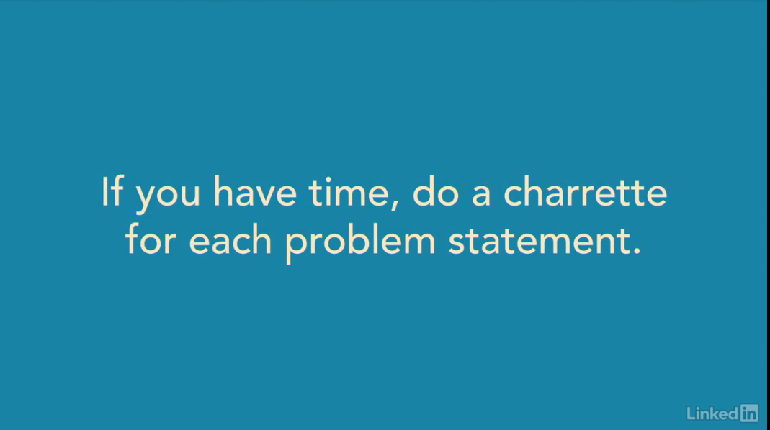

[Next, everyone on the team takes the time to individually sketch one or more product solutions.](https://www.linkedin.com/learning/ux-design-4-ideation/the-design-charrette-ideation-techniques?autoSkip=true&resume=false)

[At this point, you'll probably have team members who complain that they can't draw. They may even feel intimidated if one or more team members do have good design skills.](https://www.linkedin.com/learning/ux-design-4-ideation/the-design-charrette-ideation-techniques?autoSkip=true&resume=false)

[What's important to emphasize at this point is that you aren't wanting people to design a finished interface. In fact, their design might not show much interface at all. It might instead show the concept behind a certain interaction, or the steps involved to get a user to their solution.](https://www.linkedin.com/learning/ux-design-4-ideation/the-design-charrette-ideation-techniques?autoSkip=true&resume=false)

[Team members can draw pictures, storyboard or comic book style flows, interface elements, or if they really don't think they have any drawing ability, they can write out their concept. I like people to use large sheets of paper, tabloid or A3 size, and marker pens. The reason for this is that everyone who participates will present their idea to the group, and all the design ideas get pinned on the wall. It's important that people can see them from across the room. I also find that people get more creative if they're given a range of different color pens to use.](https://www.linkedin.com/learning/ux-design-4-ideation/the-design-charrette-ideation-techniques?autoSkip=true&resume=false)



[You may never consider using purple or bright yellow in your final interface, but at this point, it's not about interface design, so much as about idea generation.](https://www.linkedin.com/learning/ux-design-4-ideation/the-design-charrette-ideation-techniques?autoSkip=true&resume=false)

[Sometimes you'll want to arrange a design charrette session when people come to the meeting with their first design drafts.](https://www.linkedin.com/learning/ux-design-4-ideation/the-design-charrette-ideation-techniques?autoSkip=true&resume=false)

[Kind of like setting homework. However, as with homework, not everyone is going to have completed the assignment. Normally, it's better to set aside the time to have people come up with their ideas during the meeting. I normally give people just 10 to 15 minutes for this initial drawing time.](https://www.linkedin.com/learning/ux-design-4-ideation/the-design-charrette-ideation-techniques?autoSkip=true&resume=false)

[Any longer, and they start getting too fancy.](https://www.linkedin.com/learning/ux-design-4-ideation/the-design-charrette-ideation-techniques?autoSkip=true&resume=false)

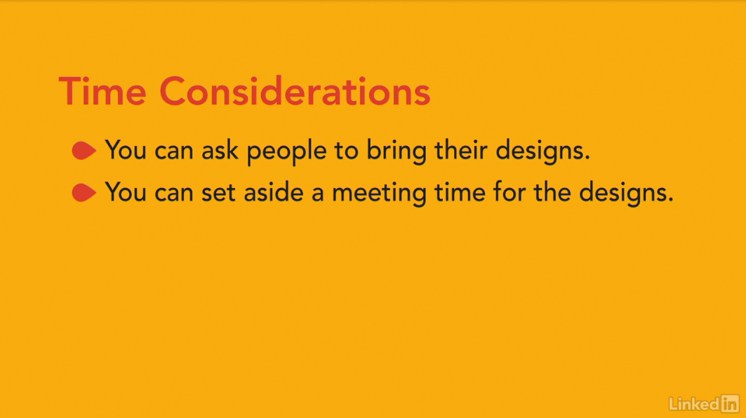

[Next, it's time to share the ideas that everyone's generated.](https://www.linkedin.com/learning/ux-design-4-ideation/the-design-charrette-ideation-techniques?autoSkip=true&resume=false)

[This is supposed to be a supportive environment. It doesn't matter how artistic someone's idea is. Instead, what's important is how creative it is, and how far it goes towards solving the pain points that you identified.](https://www.linkedin.com/learning/ux-design-4-ideation/the-design-charrette-ideation-techniques?autoSkip=true&resume=false)

[There's room in this process for critique. The idea is to draw out from each individual what it is about their design that they feel solves the issue at hand.](https://www.linkedin.com/learning/ux-design-4-ideation/the-design-charrette-ideation-techniques?autoSkip=true&resume=false)

[It's okay to ask if they've considered certain elements, and it's okay for them to answer that they did not.](https://www.linkedin.com/learning/ux-design-4-ideation/the-design-charrette-ideation-techniques?autoSkip=true&resume=false)

[You aren't looking for the one ideal solution from this part of the exercise.](https://www.linkedin.com/learning/ux-design-4-ideation/the-design-charrette-ideation-techniques?autoSkip=true&resume=false)

[Instead, you're looking for creative ideas to use as input for the next round. Partial solutions are just fine, as are wacky ideas that at first glance don't appear to be very workable.](https://www.linkedin.com/learning/ux-design-4-ideation/the-design-charrette-ideation-techniques?autoSkip=true&resume=false)

[In my experience, there are often elements of these far out concepts that are important to capture, and that can really add delight to your final design. When you've been around the room and got everyone to present their design ideas, it's time to discuss which concepts you would want to incorporate in the next round.](https://www.linkedin.com/learning/ux-design-4-ideation/the-design-charrette-ideation-techniques?autoSkip=true&resume=false)

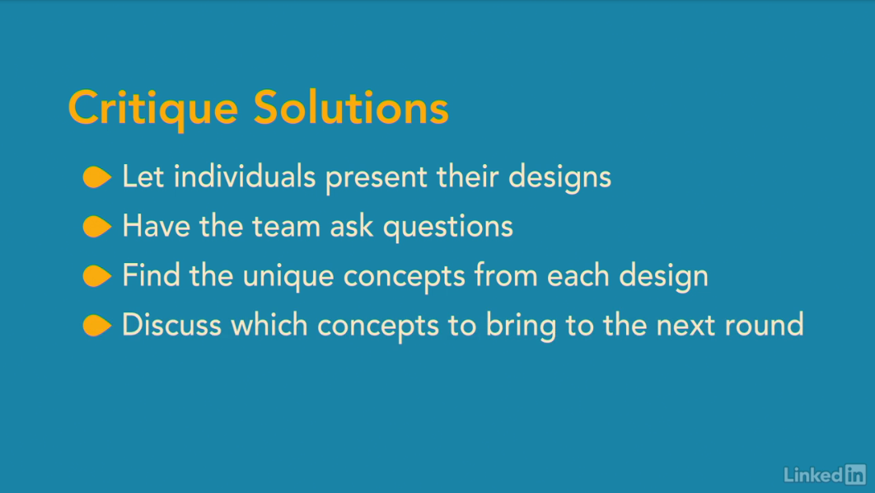

[You can do this verbally or by pinning all the ideas up on the wall and dot voting for the ones you like best.](https://www.linkedin.com/learning/ux-design-4-ideation/the-design-charrette-ideation-techniques?autoSkip=true&resume=false)

[Dot voting involves giving everyone in the room a limited number of sticky dots, say three, and then letting them spend those dots against any of the designs they choose.](https://www.linkedin.com/learning/ux-design-4-ideation/the-design-charrette-ideation-techniques?autoSkip=true&resume=false)

[An individual could put all of their dots against one design, or spread them out amongst different designs.](https://www.linkedin.com/learning/ux-design-4-ideation/the-design-charrette-ideation-techniques?autoSkip=true&resume=false)

[When you're done voting or discussing the different design ideas, it's time to move on to the next round.](https://www.linkedin.com/learning/ux-design-4-ideation/the-design-charrette-ideation-techniques?autoSkip=true&resume=false)

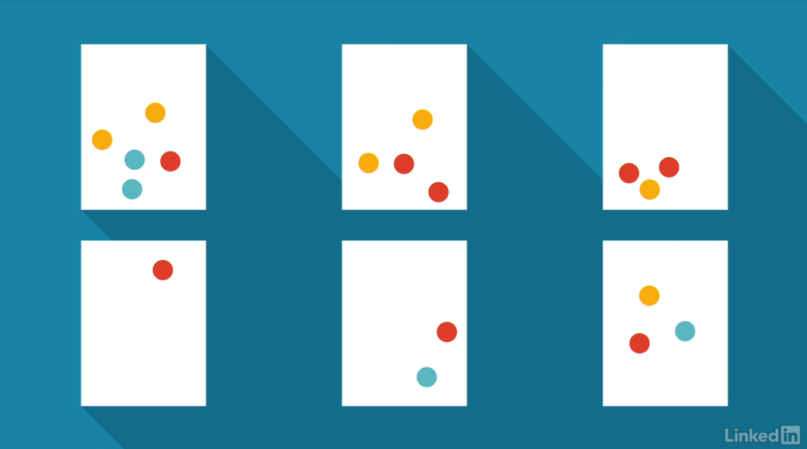

[At this point, everyone should be fueled up by the ideas they've seen and presented in the first round of designs.](https://www.linkedin.com/learning/ux-design-4-ideation/the-design-charrette-ideation-techniques?autoSkip=true&resume=false)

[Now, they have the opportunity to improve on this set of concepts by combining and re-imagining them into a new set of drawings.](https://www.linkedin.com/learning/ux-design-4-ideation/the-design-charrette-ideation-techniques?autoSkip=true&resume=false)

[For this stage, rather than working individually, I like to get people to work in pairs or small groups. This forces people to discuss the solutions they create as they come up with them, and to justify the changes to each other. It also allows people to build ofF each other's creativity.](https://www.linkedin.com/learning/ux-design-4-ideation/the-design-charrette-ideation-techniques?autoSkip=true&resume=false)

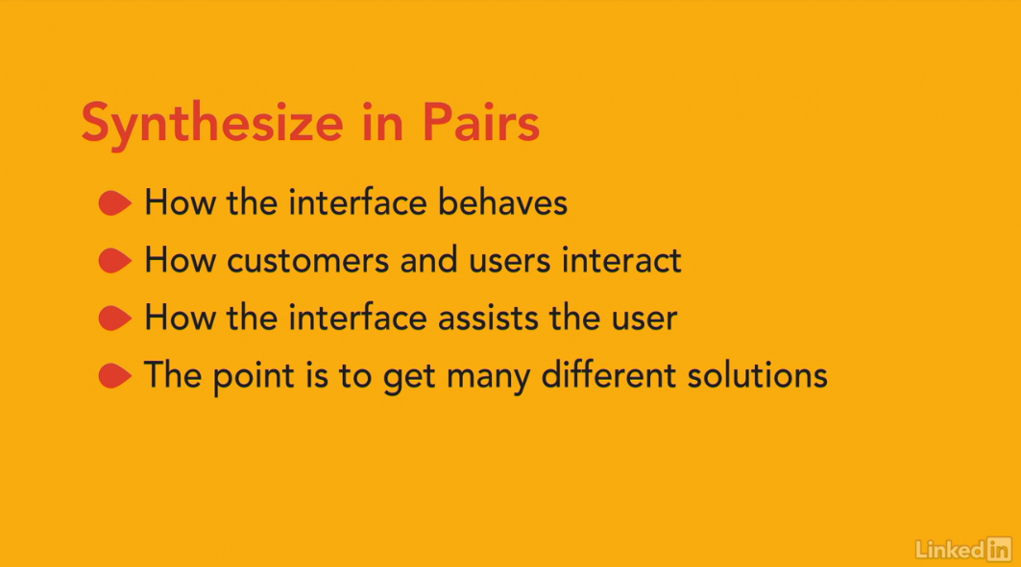

[This synthesis stage is still about creativity rather than interface design.](https://www.linkedin.com/learning/ux-design-4-ideation/the-design-charrette-ideation-techniques?autoSkip=true&resume=false)

[Each group's solution might end up being more of a sketch of how the interface might behave, but it doesn't have to be. It could equally well cover the interaction of a customer with the individual using the interface. Or of how the interface assists the user in carrying out their task.](https://www.linkedin.com/learning/ux-design-4-ideation/the-design-charrette-ideation-techniques?autoSkip=true&resume=false)

[If this sounds like an imprecise description to you, that's on purpose. Different people on the team will think in different ways about the problems that you're trying to solve. Often, by immediately moving to interface designs, we cut those people off from contributing to the solution.](https://www.linkedin.com/learning/ux-design-4-ideation/the-design-charrette-ideation-techniques?autoSkip=true&resume=false)

[By leaving the scope of the drawings wide or ambiguous, we give people the opportunity to present their ideas in whichever way makes most sense to them.](https://www.linkedin.com/learning/ux-design-4-ideation/the-design-charrette-ideation-techniques?autoSkip=true&resume=false)

[There'll be plenty of time later on to translate these novel ideas into form fields, radio buttons and check boxes.](https://www.linkedin.com/learning/ux-design-4-ideation/the-design-charrette-ideation-techniques?autoSkip=true&resume=false)

[Once again, after the second round of design sessions, the team should get back together to present and critique each idea.](https://www.linkedin.com/learning/ux-design-4-ideation/the-design-charrette-ideation-techniques?autoSkip=true&resume=false)

[At this point, you'll probably have some understanding of which ideas you're likely to carry forward into prototypes.](https://www.linkedin.com/learning/ux-design-4-ideation/the-design-charrette-ideation-techniques?autoSkip=true&resume=false)

[But we aren't ready to build the prototypes yet.](https://www.linkedin.com/learning/ux-design-4-ideation/the-design-charrette-ideation-techniques?autoSkip=true&resume=false)

[Without exploring the full interaction between users and the system, we have no way of knowing that we've covered all of the elements of the interaction.](https://www.linkedin.com/learning/ux-design-4-ideation/the-design-charrette-ideation-techniques?autoSkip=true&resume=false)

[Before we create user interfaces, we need to describe the back and forth between the user and the system, up one more level of detail.](https://www.linkedin.com/learning/ux-design-4-ideation/the-design-charrette-ideation-techniques?autoSkip=true&resume=false)

[For that, we use scenarios and storyboards, which are the topic of the next course in this series. Before we get to those though, it's worth exploring some other ideation techniques that you can use instead of, or in combination with design charrettes.](https://www.linkedin.com/learning/ux-design-4-ideation/the-design-charrette-ideation-techniques?autoSkip=true&resume=false)

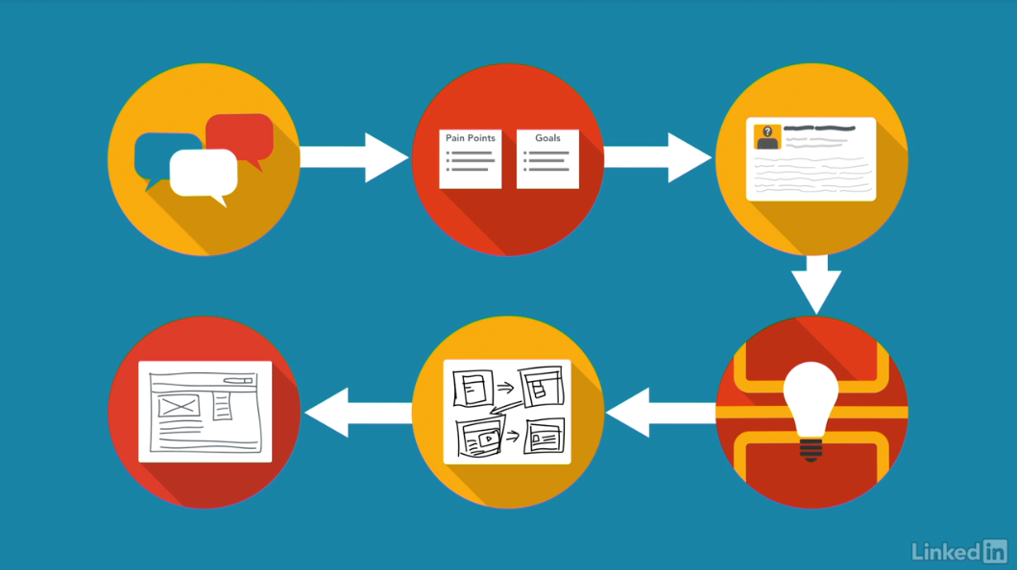

**Alternatives ideation techniques to try**

[Another technique that sometimes works if group members really don't want to draw things, is the Possible Futures approach.](https://www.linkedin.com/learning/ux-design-4-ideation/alternatives-ideation-techniques-to-try?resume=false)

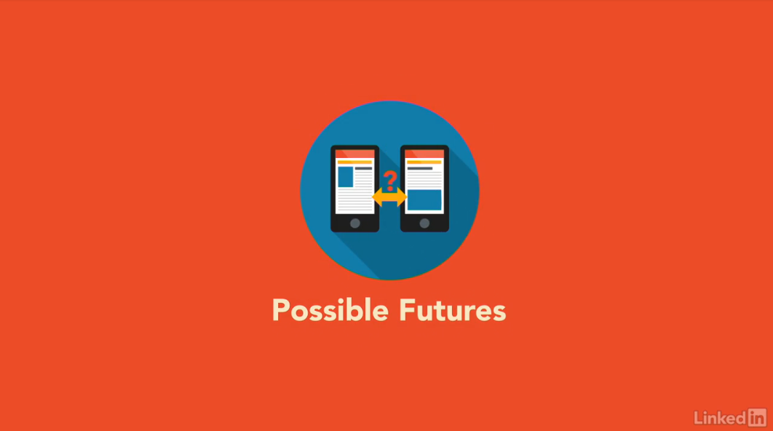

[Here, we use a similar setup to the design charette, but the starting point for the creativity happens when each individual shows how a mash-up of two existing products or technologies, would create a solution for the current issue.](https://www.linkedin.com/learning/ux-design-4-ideation/alternatives-ideation-techniques-to-try?resume=false)

[For instance, combining location awareness services and wish lists could lead to a concept for prompting people when they are close to a store that sells something a friend wants for their birthday.](https://www.linkedin.com/learning/ux-design-4-ideation/alternatives-ideation-techniques-to-try?resume=false)



[Or, combining a Twitter feed and mood analytics software could lead to a concept for a chocolate delivery service when you need it most.](https://www.linkedin.com/learning/ux-design-4-ideation/alternatives-ideation-techniques-to-try?resume=false)

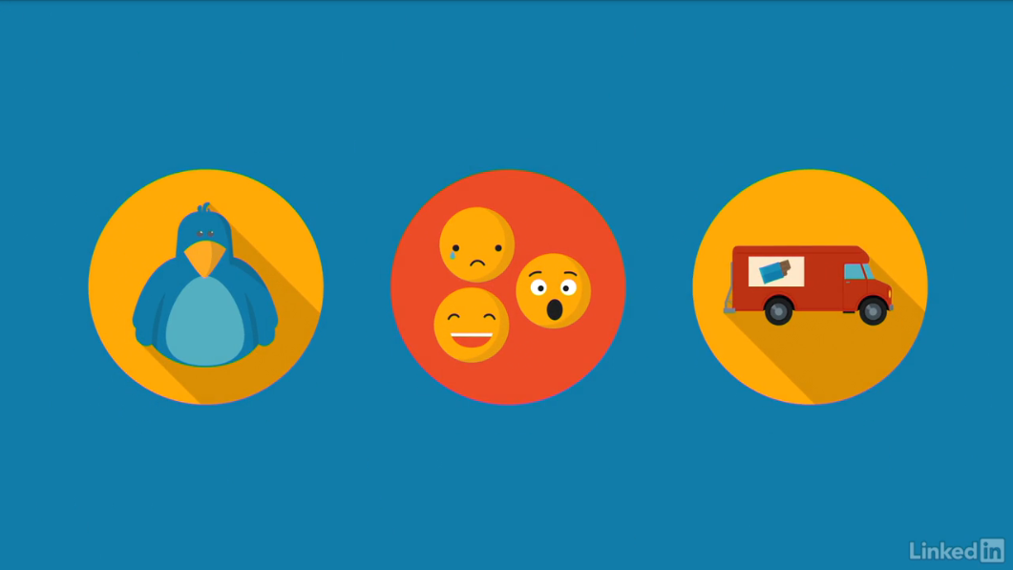

[The team then uses this type of input for a design charette-style ideation exercise.](https://www.linkedin.com/learning/ux-design-4-ideation/alternatives-ideation-techniques-to-try?resume=false)

[Also, it's possible to ask each team member to bring existing products or designs as examples.](https://www.linkedin.com/learning/ux-design-4-ideation/alternatives-ideation-techniques-to-try?resume=false)

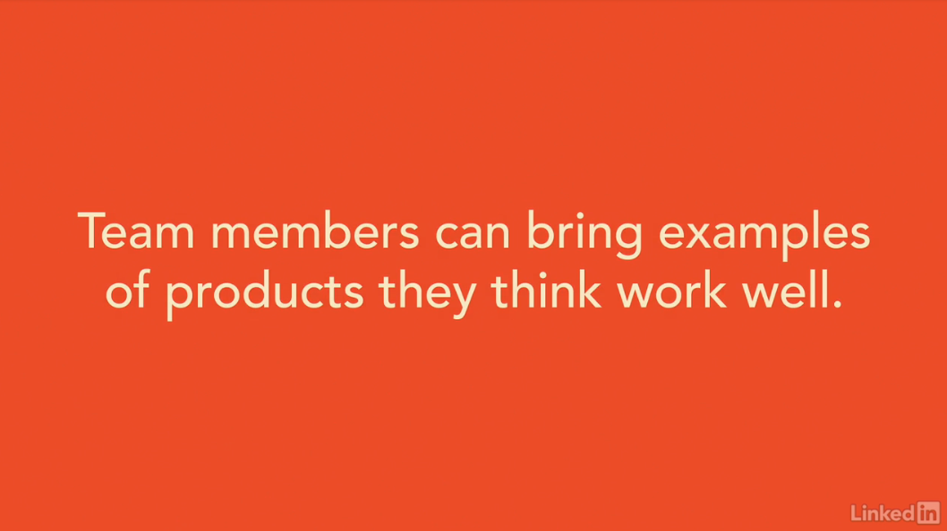

[This doesn't mean you're going to be copying other people's work, you're using these designs as inspiration.](https://www.linkedin.com/learning/ux-design-4-ideation/alternatives-ideation-techniques-to-try?resume=false)

[The designs may even be from a completely different market, but people on the team bring them in to demonstrate the one thing that they do well, that you'd like to also do well.](https://www.linkedin.com/learning/ux-design-4-ideation/alternatives-ideation-techniques-to-try?resume=false)

[There are multiple other variations, I've worked with teams using modelling clay, foam cutouts, and other similar three-dimensional items, to describe how the interaction should progress.](https://www.linkedin.com/learning/ux-design-4-ideation/alternatives-ideation-techniques-to-try?resume=false)

[Although you might think that this would only be useful for real-world products, it's often a great way to get around a mental block that the team has about an interface design.](https://www.linkedin.com/learning/ux-design-4-ideation/alternatives-ideation-techniques-to-try?resume=false)

[Taking that a stage further, it's also sometimes fun to get the team to act out the interface.](https://www.linkedin.com/learning/ux-design-4-ideation/alternatives-ideation-techniques-to-try?resume=false)

[By that, I mean getting each person to play the role of part of the system.](https://www.linkedin.com/learning/ux-design-4-ideation/alternatives-ideation-techniques-to-try?resume=false)



[One person might be the customer, another would be the company representative, then, there would be the computer terminal that the company representative uses, the database, and other digital assets.](https://www.linkedin.com/learning/ux-design-4-ideation/alternatives-ideation-techniques-to-try?resume=false)

[If each actor remains relatively serious about their role, it's a fun way of seeing how each part of the system interacts, and what it would take to make that system work better together.](https://www.linkedin.com/learning/ux-design-4-ideation/alternatives-ideation-techniques-to-try?resume=false)

[For instance, if the person playing the role of computer interface, keeps asking the database person for information that they don't have access to, that suggests there's a gap in the back-end design.](https://www.linkedin.com/learning/ux-design-4-ideation/alternatives-ideation-techniques-to-try?resume=false)

[If the customer ends up trying to have a side conversation with one of the other digital assets, it suggests that the information flow needs to behave differently.](https://www.linkedin.com/learning/ux-design-4-ideation/alternatives-ideation-techniques-to-try?resume=false)

[How far you take this kind of ideation exercise is up to you, and to your understanding of the personalities on your team.](https://www.linkedin.com/learning/ux-design-4-ideation/alternatives-ideation-techniques-to-try?resume=false)

[You might not want to start them off with freeform improvisational theater, but once you've been through the design charette process a couple of times, and the team becomes more confident about the iterative process of creation, critique, improvement, and more critique, they should soon open up to the potential different ideation methods.](https://www.linkedin.com/learning/ux-design-4-ideation/alternatives-ideation-techniques-to-try?resume=false)

**Conclusion**

**Getting creative ensures you don’t miss a great idea**